**Figure D**. Geographical maps of HPV vaccination rates on Long Island, New York (Nassau and Suffolk Counties) among children ages 9-13 by zip code. The rate was calculated by the number of children receiving one or more HPV vaccine dose divided by the number of children who received HPV, Tdap or both vaccines.

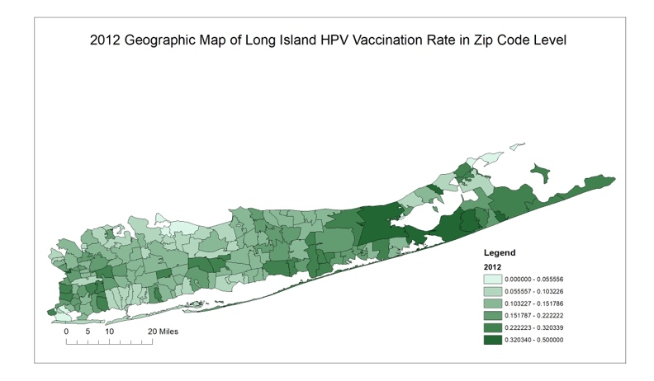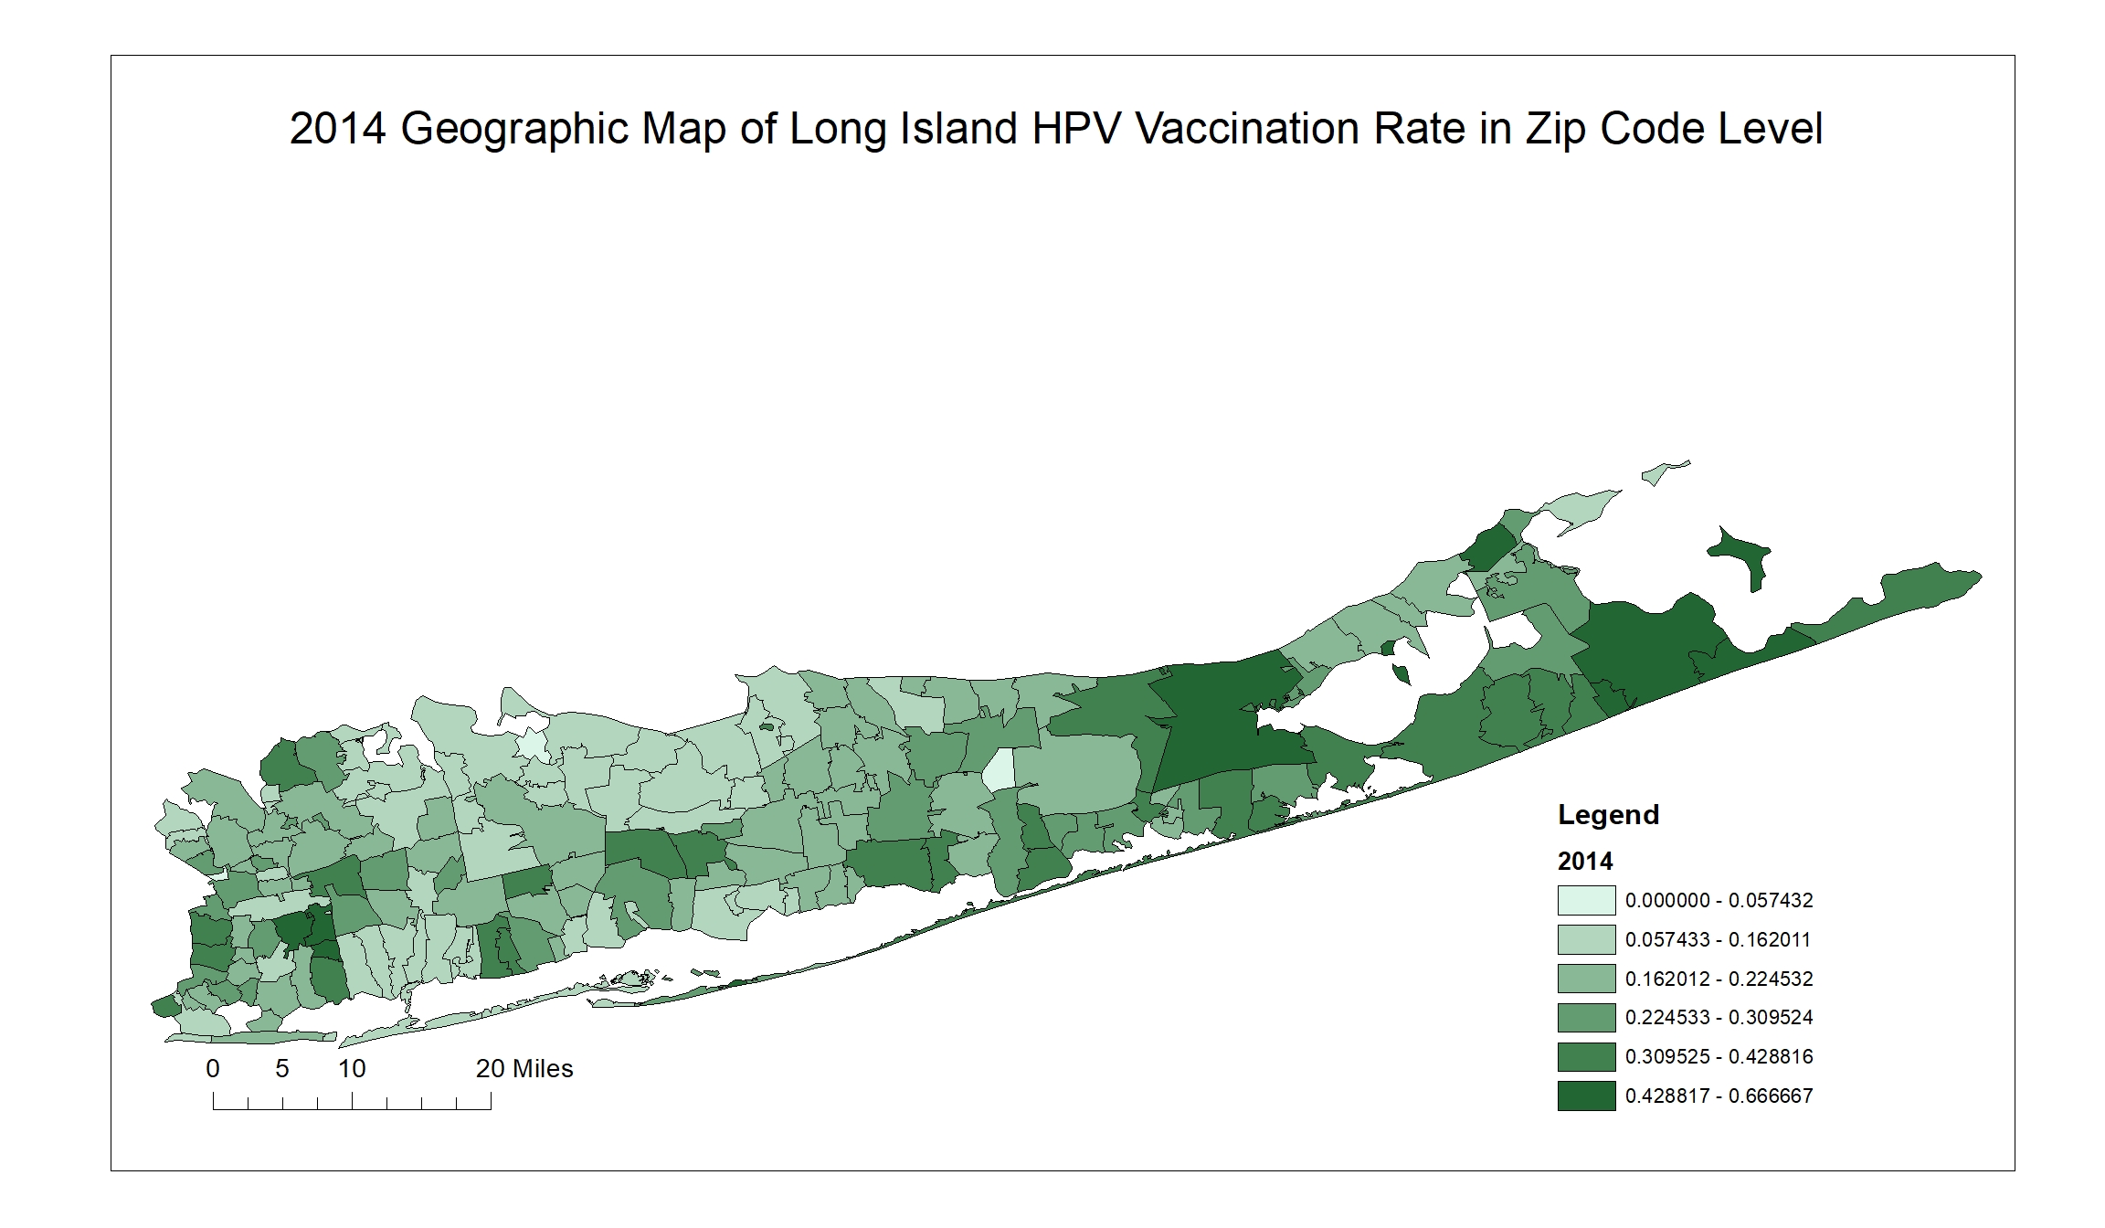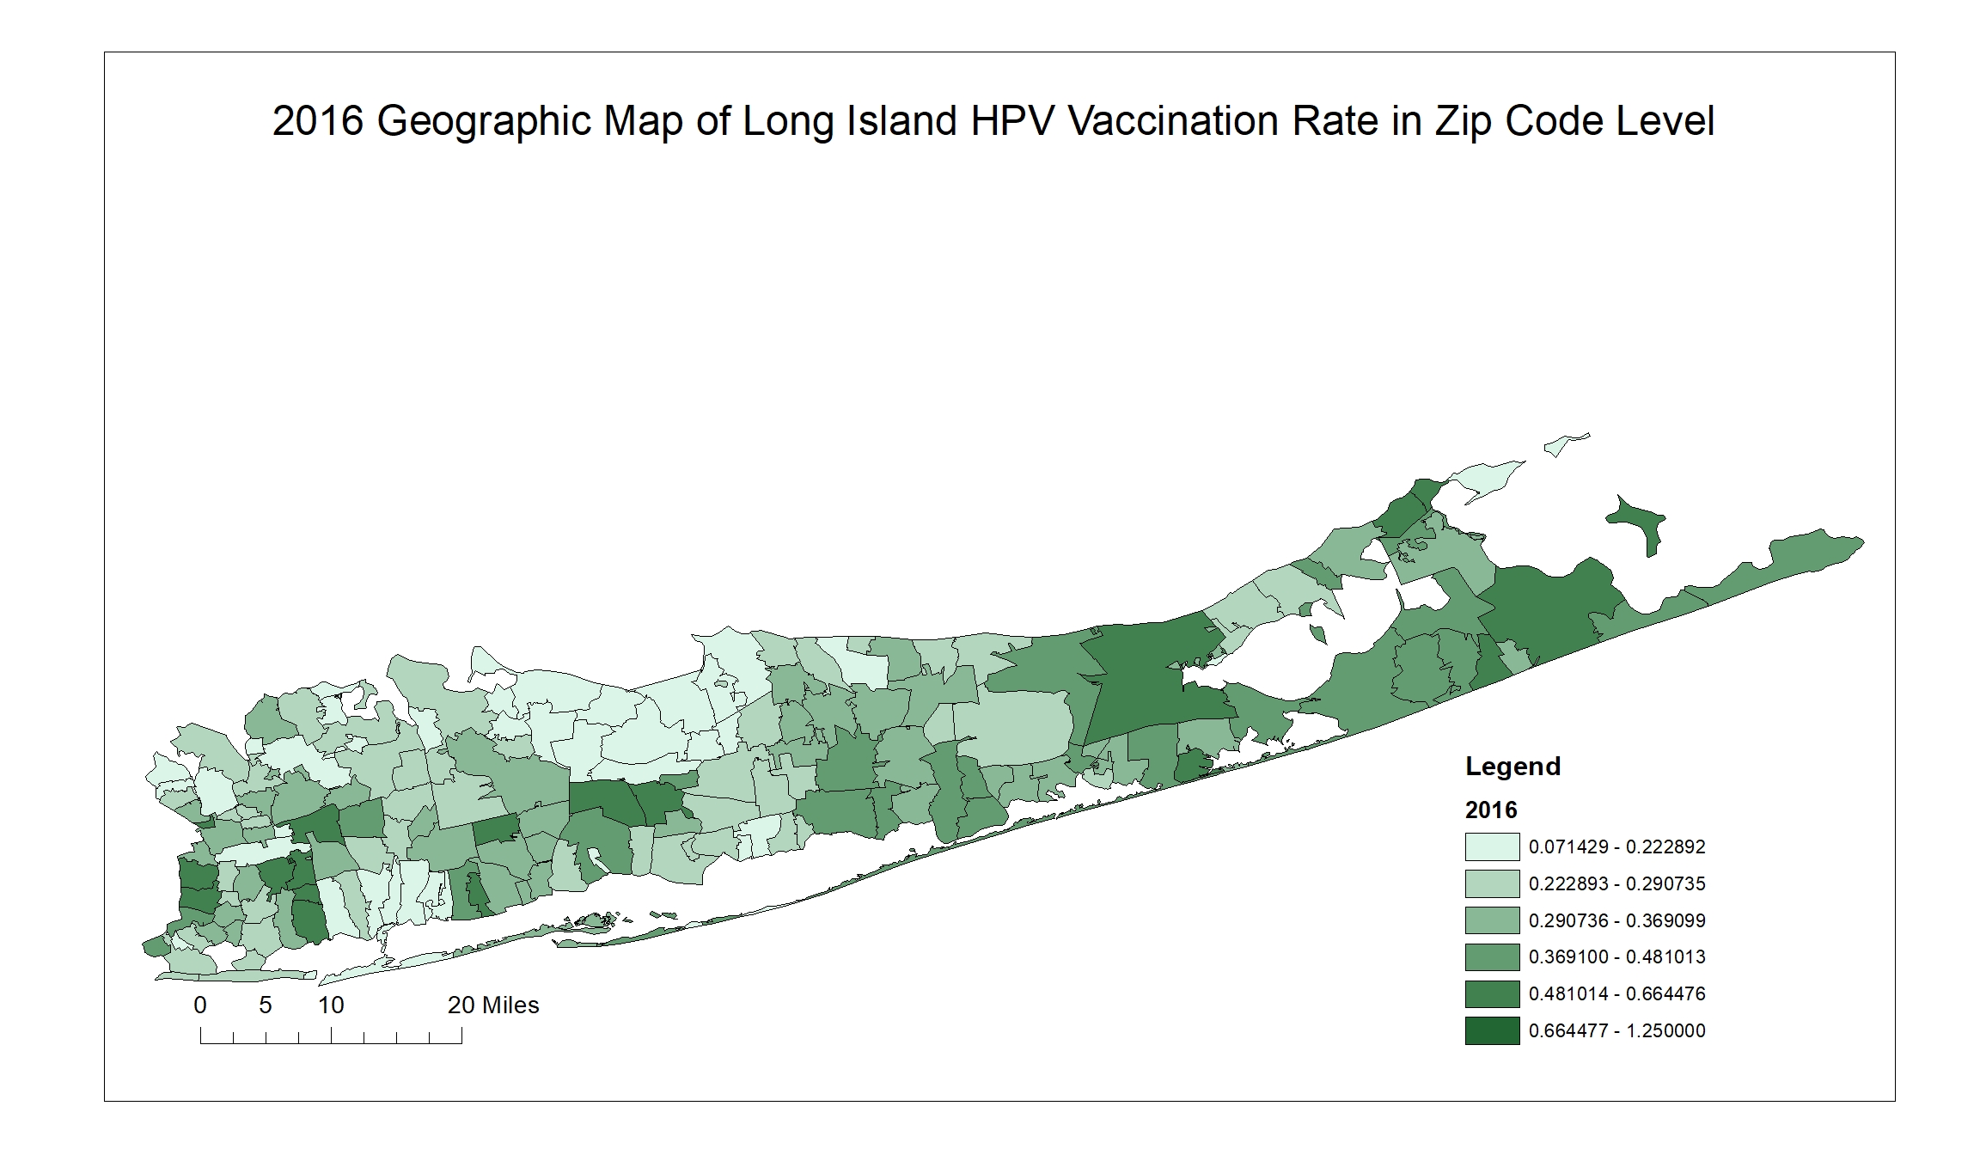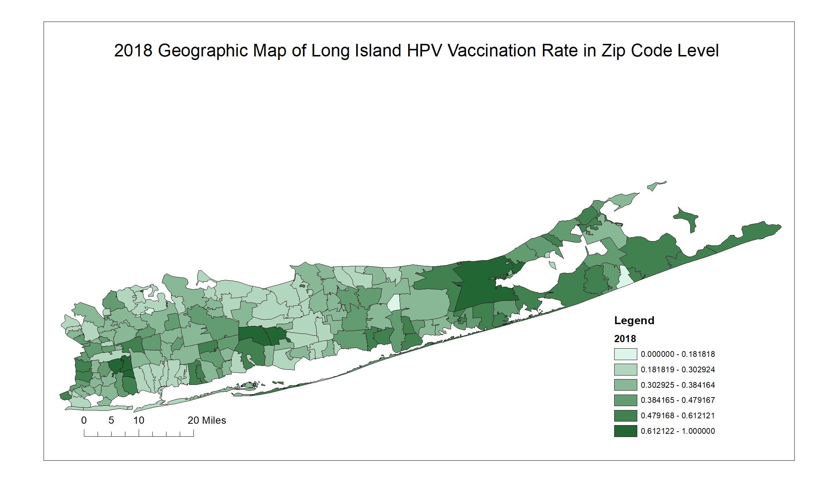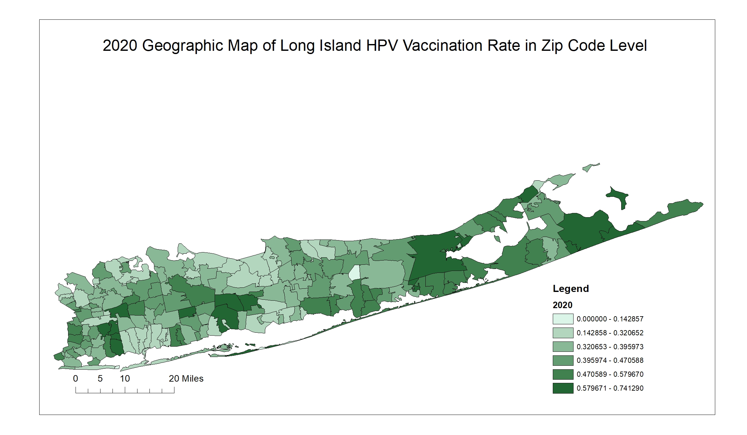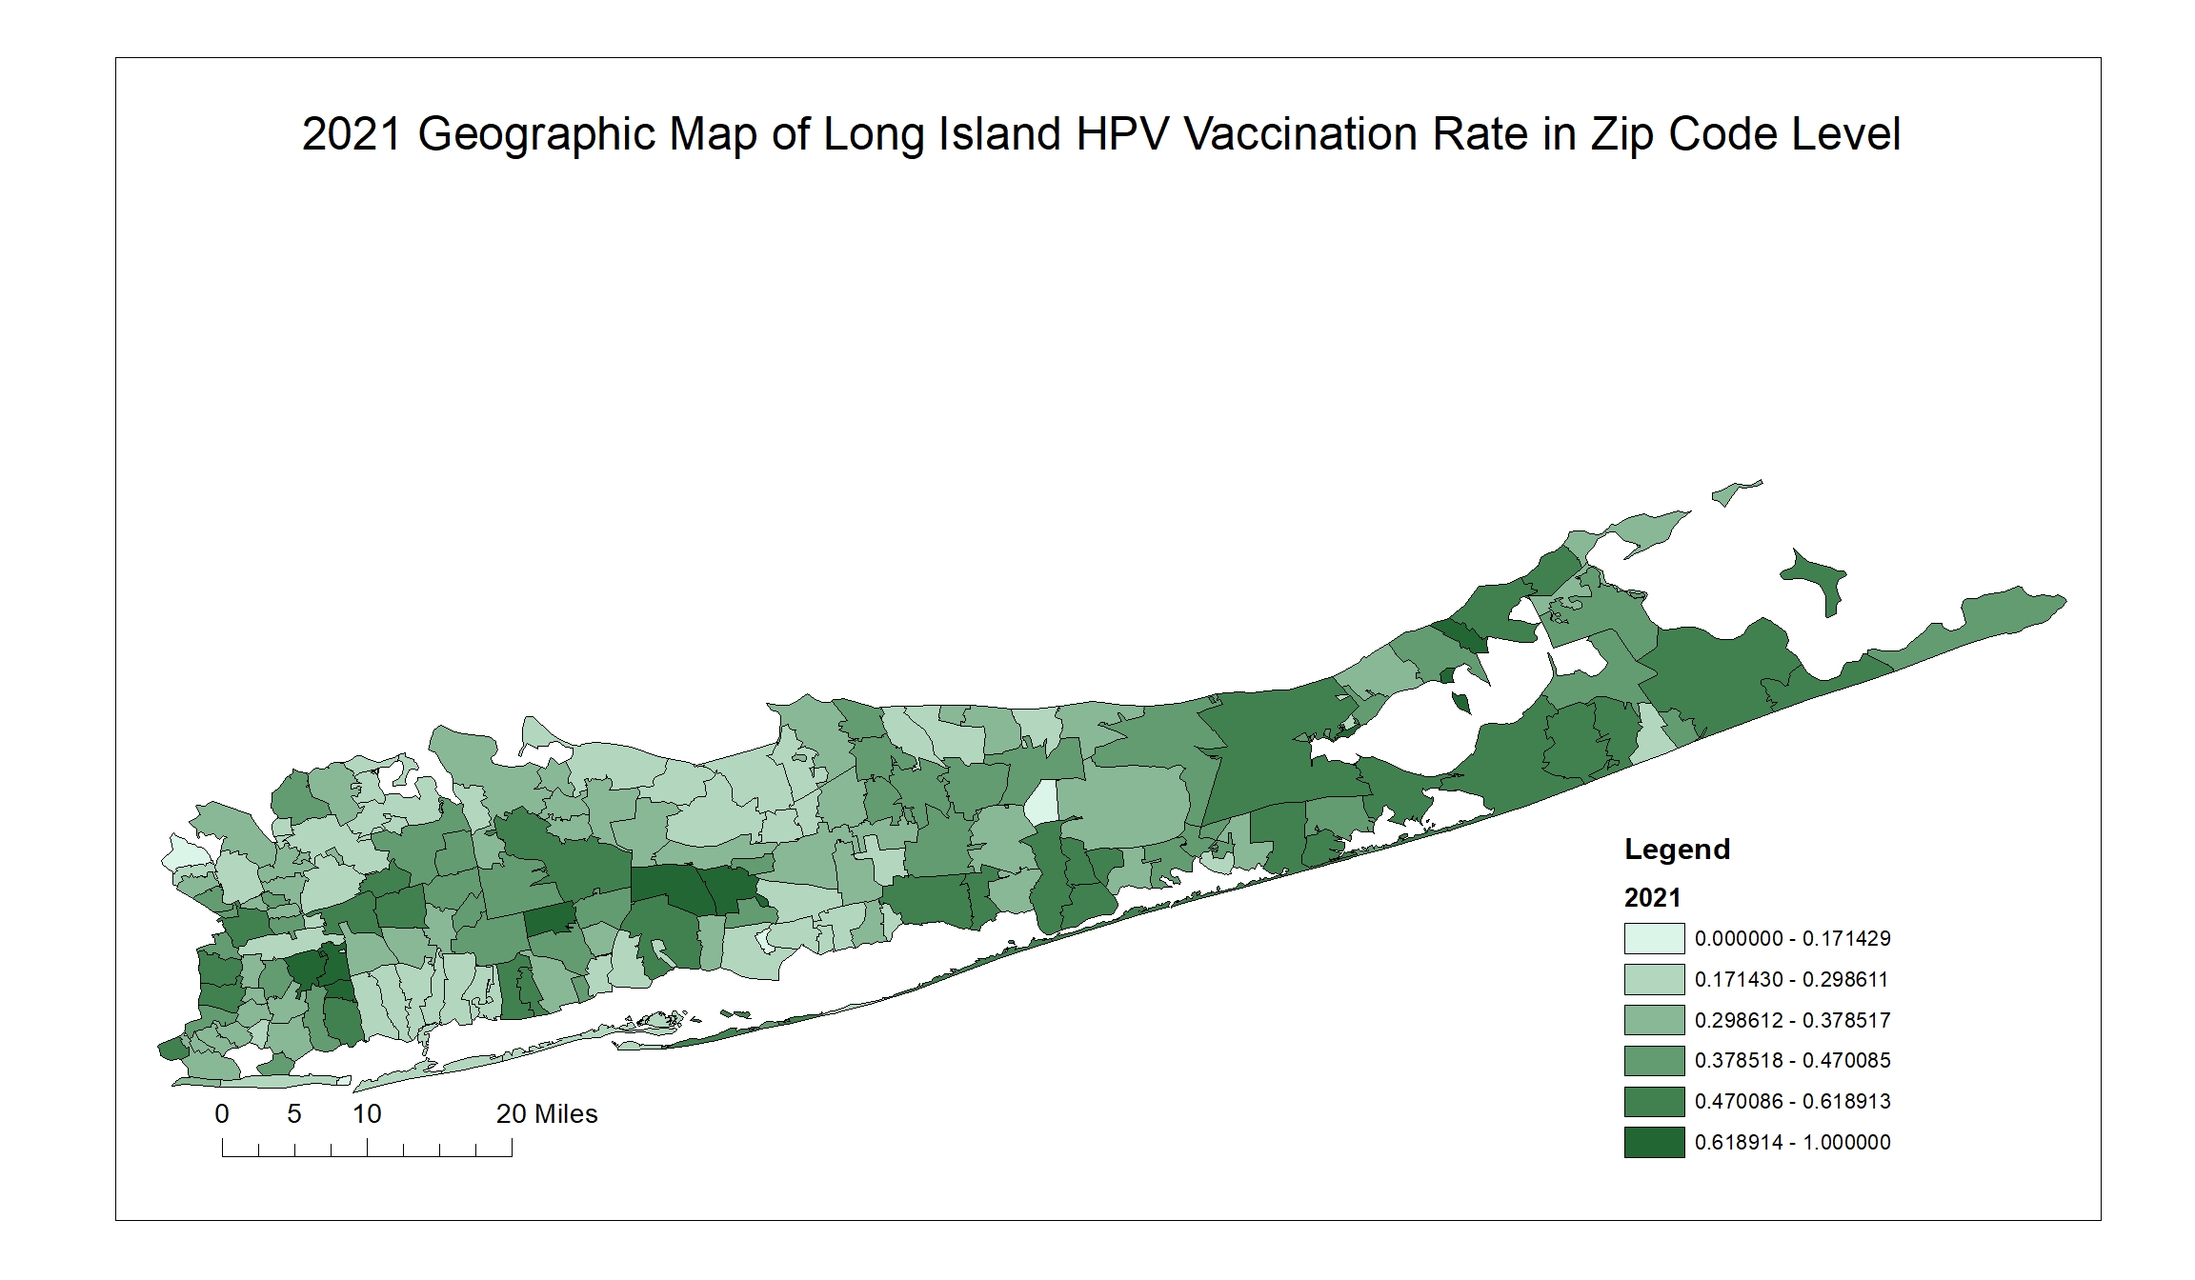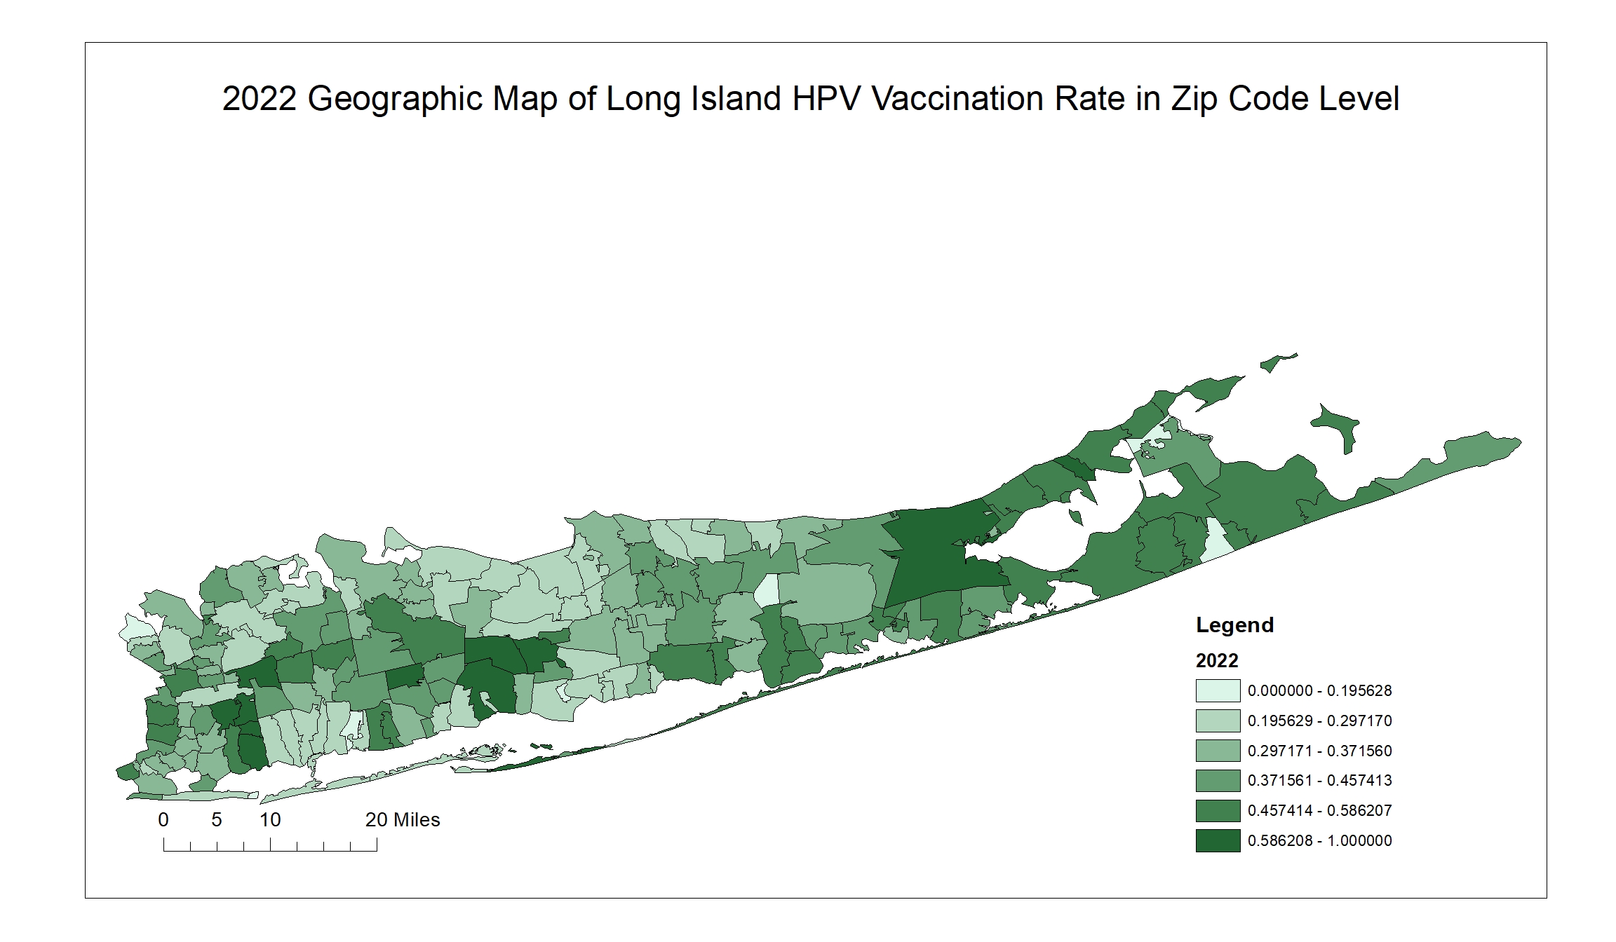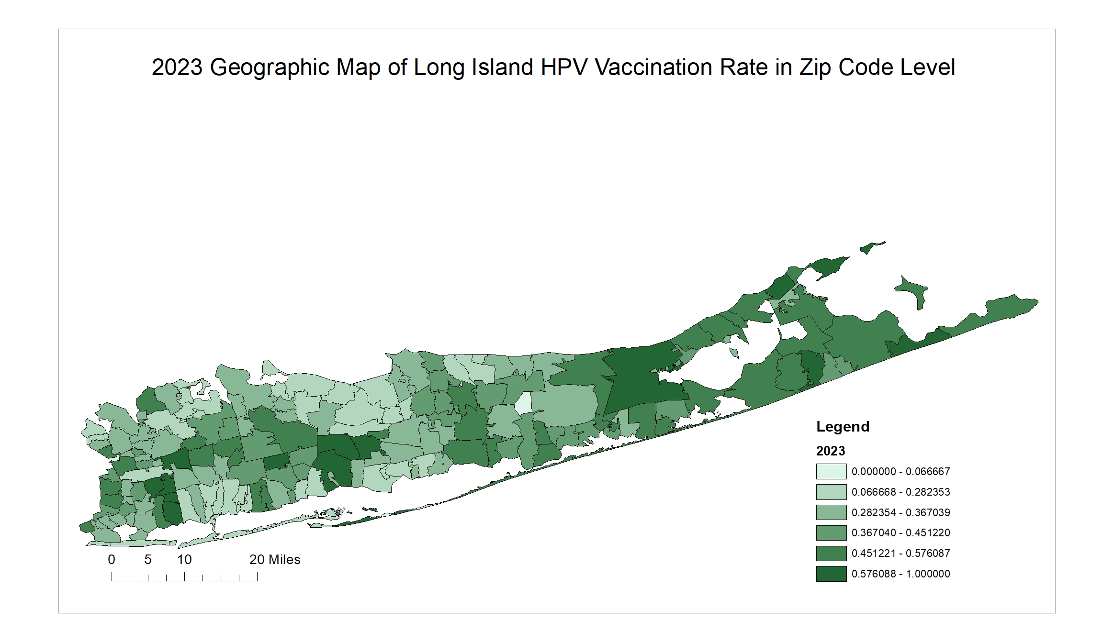

(A)

(B)

(C)

(D)

(E)

(F)

(G)

(H)